International Spring Semester
2024

War Studies English Language

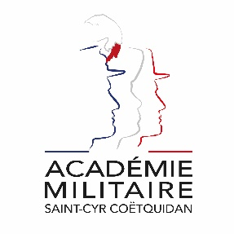
Military Academy of Saint-Cyr Coëtquidan

ERASMUS ID CODE | FGUER01
Contact | Lieutenant (OF-1) Charlie OFFERLIN  Mail : cyr.international@st-cyr.terre-net.defense.gouv.fr  Phone : +33 2 97 70 73 75
Dates | Starts : 24th January 2024  Ends : 14th June 2024  Arrival date : 23rd January 2024 (Kindly respect this date)  Dates might evolve
Student Requirements | English language B1 or 785 TOEIC
Application file | - Application form  - Medical Certificate  - Reduced Medical Booklet  - ID or Passport scan  - 1 ID photograph  Applications must be sent no later than 18th December 2023.
Meals & Accommodation | According to EMILYO-LoD 5 (framework), accommodation, meals, and other expenses in relation to the education are free of charge for members of European Union Basic Officer Education Institutions (http://www.emilyo.eu/node/982).

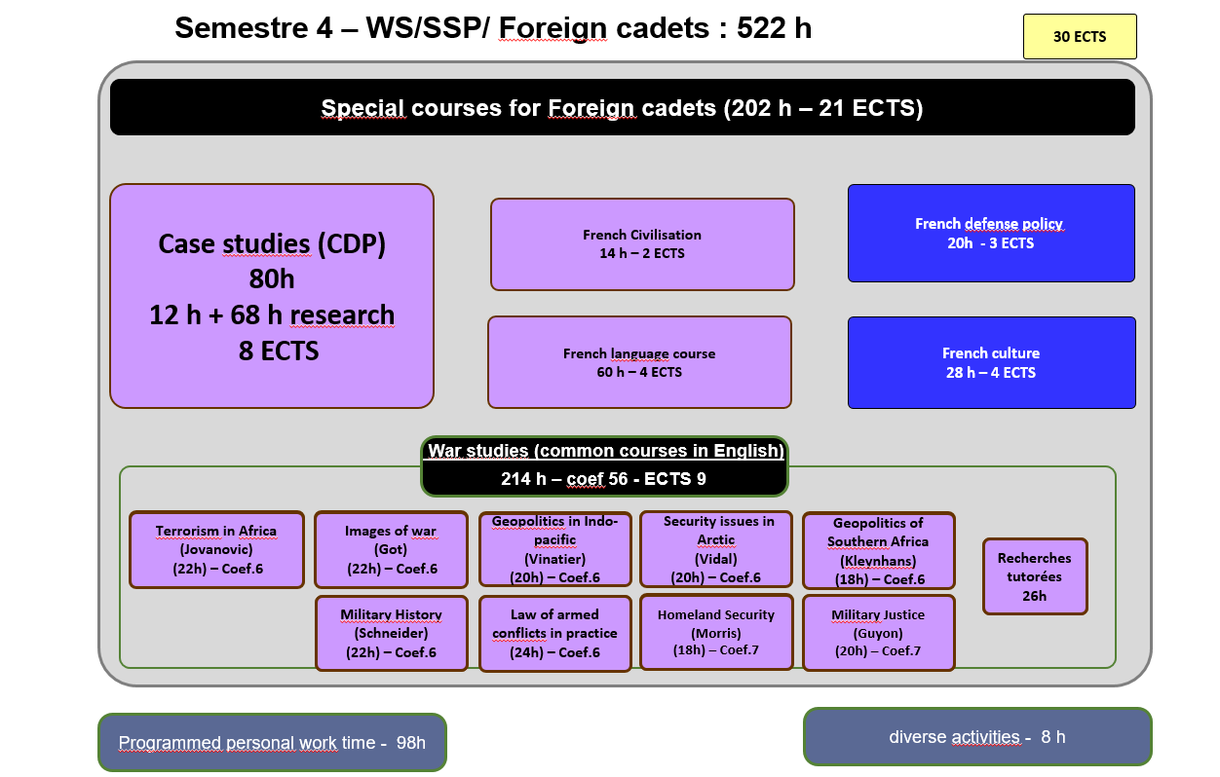
Courses Syllabus

COMMON CORE CURRICULUM

- CASE STUDIES
During this course cadets will be dispatched in teams to work on a current operation of French forces, analyse the situation and present an operation briefing.

- FRENCH CULTURE
This course provides cadets with a better knowledge of France through a mix of lessons and presentations in English on history, geography and culture of France.

- FRENCH LANGUAGE COURSE
The course offers an overview of the French military. The various lectures focus on the current French Defense policy (including the most recent White Paper, and ongoing operations), the organization of the three services and their capabilities. A particular emphasis is laid on the Army (organization, recent engagements, equipment, Special Forces and the Foreign Legion).

- FRENCH MODERN LANGUAGE
This French language course is adapted according to the level of the student. Beginner courses, aim to familiarize with the basics of written and oral French language, through targeted and personalized exercises. Confirmed levels, enable students to strengthen their linguistic skills, through exercises and the study of authentic audio and written documents (films, programs, articles, books). For both levels, the aim of this course is to provide students with notions of civilization and contemporary French culture.

- FRENCH CIVILISATION
This course, delivered entirely in French is designed to provide foreign cadets with an understanding of French and French speaking culture, through geography, history, political institutions and cultural notions. Students will also be asked to work on a presentation in French on a topic of their choosing related to French culture or institutions.

SPECIALITY COURSES IN ENGLISH

Terrorism in Africa
Radicalization: is there a possible reversal? What makes a terrorist? De-radicalization programs. A study of the area of operations: Physical and human geography of the Sahelian strip; Nigeria, Niger, Chad and Cameroon; The Lake Chad Basin; Violence or the plague of Nigeria. Players of the drama: Boko Haram; Other terrorist organizations; The local armed forces and their auxiliaries; The population; The authorities; The international community (UNO, UNHCR, UNICEF, EU); US, UK and France; NGOs (ICRC, others). A logic leading to catastrophe: Sequence of events. 2002 to 2009: a sect is born; 2009 to 2014: growing in secret; 2014 to 2017: rise and fall of the caliphate; Since 2017: no way out.

Images of War
The aim of the course is to discover the weight of representations on the conduct of war. What are the relations between the graphic arts and war. How have arts been used to the conduct of war? How have officers used their technical skills to represent military situations?

Geopolitics in Indo-pacific
The aim of the course is to have a study in depth of both concept and reality by focusing on main actors: states such as the US, China, India, Japan, Australia, France and the EU; regional organizations; TransNational Companies; NGOs and transnational organized crime. They key issues will be regional order, strategy and vision, diplomacy, policies, cooperation and integration, military tensions, piracy, terrorism, energy resources, natural resources, major shipping routes, submarine cables, migration patterns and remittances. The methodology is based on many case-studies of sub regions and strategic chokepoints: the Malacca Strait, the Taiwan Strait, the South China Sea, the East China Sea, the Indian Ocean, the horn of Africa and the Strait of Bad-el-Mandeb, the Strait of Hormuz, the Indian subcontinent, Australia, New-Zealand and the Pacific islands. Teamwork, cooperative spirit and team communication skills will be required.

Security issues in Arctic
This course will provide a baseline understanding of security circumstances and management, as well as the variety of actors involved.
Arctic Security Fundamentals also explores the security situation of the Arctic through a focus on the key stakeholders responsible for diplomacy and defense. Although the post-Cold War Circumpolar North has remained mostly stable, rapid changes in climate and technology have created new conditions requiring increased attention and management.
Cadets will learn about the complex landscape of international norms and processes governing security in the Circumpolar North, as well as the balance of diplomacy and defense that nations employ to manage priority interests. Students will explore how the three realms of international relations—cooperation, competition, and conflict—interact in this unique environment.

Geopolitics of Southern Africa
Focusing on the major geopolitical variables affecting South Africa’s ability to sustain power, the the course analyzes the economic and geographic factors that contribute to asymmetrical relationships and examine the pluralism that divides South African society. In addition, the course provides a detailed analysis of South Africa’s minerals-based economy and discuss the implications for regional stability of economic sanctions against South Africa. Finally, it outline a policy framework that takes regional economic, political, and geographic realities into account.

Military History
This course will be given by a professor in History at Westpoint and will be divided in two parts. The first one will be dedicated to Napoleonic wars in Europe. The second one to the history of the American Army since the Vietnam War.

Law of Armed Conflicts in practice

In a first part, the International Committee of the Red Cross will give a short course on Law of Armed Conflicts and its application in current conflicts. Then, with the assistance of the Red Cross, cadets will have to elaborate concrete scenarii of IHL in practice and compare them.

Homeland security
This course will study Homeland security, policing, peacekeeping, counterterrorism, and counter-insurgency and how crime intersects with formal and informal justice systems in a socio-cultural context. It will also consider information warfare, especially in Americano-chinese relations. -cultural context.

Military justice
This course investigates the subject from a flank that has not been approached in any formally deliberate way to date. It will draw from the vast forest of military professionals, lawyers, scholars, and courts, describing parts or all of military justice, a sense of the underlying logic that has purported to justify, historically, the distinctive attributes that separate what it means to be under the criminal jurisdiction of the military from what it means to be under that of the civilian state government and local law enforcement authorities. The aim of the course is to identify how that logic seems contrary to contemporary public explanations of military justice’s animating purpose, in particular the U.S. Supreme Court’s most recent description of military justice in 2018. Lastly, it will explore how those arguments that seem to express confidence in military justice, placing it on the same moral and legal plane as “normal” civilian justice, ironically undermine the very justifications for keeping the most prominent characteristics of modern military criminal law intact.

Application file documents:

- Application Form (p.9)

- Medical Certificate (p. 10)

- Reduced Medical Booklet (p. 11 – p.12)

Application Form

Military Academy of Saint-Cyr Coëtquidan
Please attach your head-and-shoulder photograph data.
Country of Origin:
Name of the Institute:

Course:
From:  (dd/mm/yy) |  | To:  (dd/mm/yy)

Male | Female | Rank | Surname | First name

Date of birth | Place of birth | Branch of Service | Major academic Field | Academic Year

Passport number | Phone number | e-mail address
ID number | Current address

Arrival at Rennes Airport (yes/no) | Arrival at Rennes rail station  (yes/no) | Arrival date (dd/mm/yy) | Time of arrival
Departure from Rennes Airport  (yes/no) | Departure from Rennes rail station  (yes/no) | Departure date (dd/mm/yy) | Time of departure

Special dietary or food requirements

Emergency contact/ Liaison staff:
Male | Female | Rank | Surname |  | First name
POC’s phone number |  |  |  | POC’s e-mail address

FRENCH MINISTRY OF DEFENSE

-------------------------
MILITARY HEALTH SERVICE

--------------------------
MEDICAL CERTIFICATE
(n°620-4/1)

SURNAME : FIRST NAME :

Birth date : Rank :

APTITUDES | Medical decision
General

Abroad & overseas

Paratrooper

Commando

Job’s restriction details
(if needed)

CONCLUSION: Date:
⁭ Aptitude without restrictions
⁭ Aptitude with restrictions Practitioner’s signature & stamp:
⁭ Inability

Reduced Medical Booklet

Surname: First Name:

Birth Date: Rank:

Medical Background
- Family :

- Medical :

- Surgical :

- Allergy :

Treatment :

Current Medical condition :

Job’s incapacity :

Height: Weight:

Blood Pressure: Pulse:

VACCINATION:

TYPE | Date of 1st injection | 2nd injection | 3rd injection
BCG
Diphtheria-Tetanus-Polio-Pertussis
Meningitis (A + C)
Hepatitis B
Measles-Mumps-Rubella
INFLUENZAE (H1N1 and seasonal)
Meningococcal Tetravalent (A + C + Y + W135
Typhoid
Hepatitis A
Yellow fever

Date : Practitioner’s stamp and signature :

